

Cycle Counting

QAD EE 2016

Table of Contents
Objective 3
Process Steps 4
Creating a plan 5
Activating the plan: 3.13.20.2 7
Counting and recording results 7
Location complete: 3.13.20.11 11
Pack quantity correction: 3.13.20.4 11
Counting Status Update: 3.13.20.5 11
Reviewing counting results: 3.13.20.6 12
Recounting and recording recounting results 12
Updating Status after recounting: 15
Processing cycle counting results: 3.13.20.7 15
Checking counting results in Transaction History: 3.21.2 16
Updating Inventory Master via *Location Check for RA Plan Code (3.13.20.16) ………………………………. 16
Miscellaneous Details ……………………………………………………………………………………………………………………… 17

Objective
Purpose of this document is to explain the cycle counting process in QAD.
Refer to the current BOS document on Cycle Counting for more details of the current standards: Inventory Reconciliation procedure

Important information
- Inventory will not be “Frozen” during cycle-counting, so all normal plant activities are still allowed during counting (including replenishment, backflushing, receiving and shipping).
- Do not use standard cycle-counting transactions together with this process. If you need to correct inventory outside of counting plan – use Issue Unplanned programs.
- Do not move any materials manually to/ from CYC-DIFF locations. More information below.

Customized tables:-

xccpl_mstr | Plan Code Master
xccs_mstr | Summary Table
xccd_det | Scan Detail Table

Process Steps
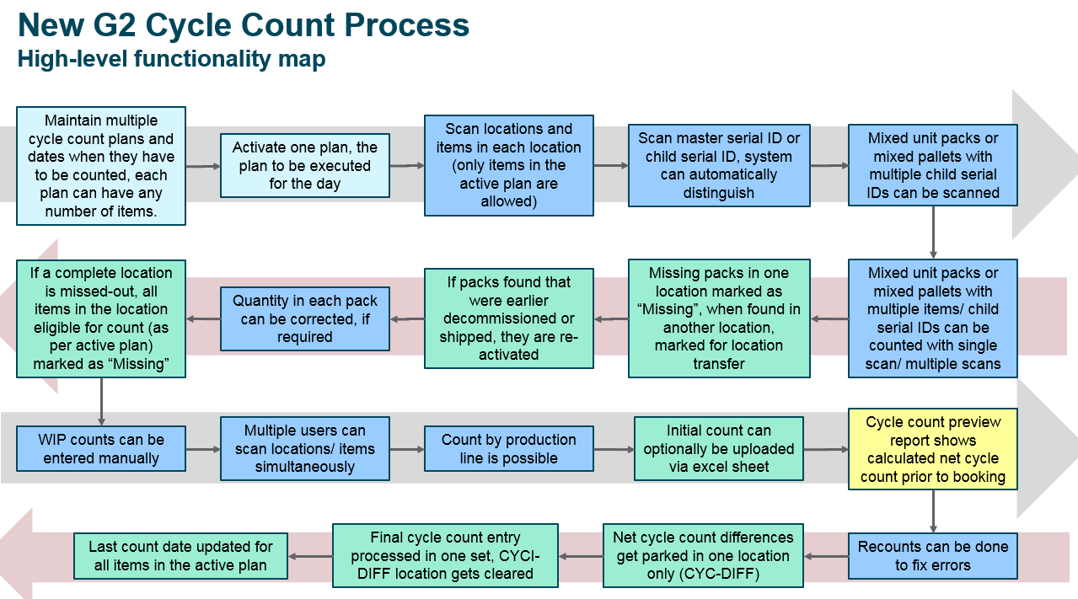

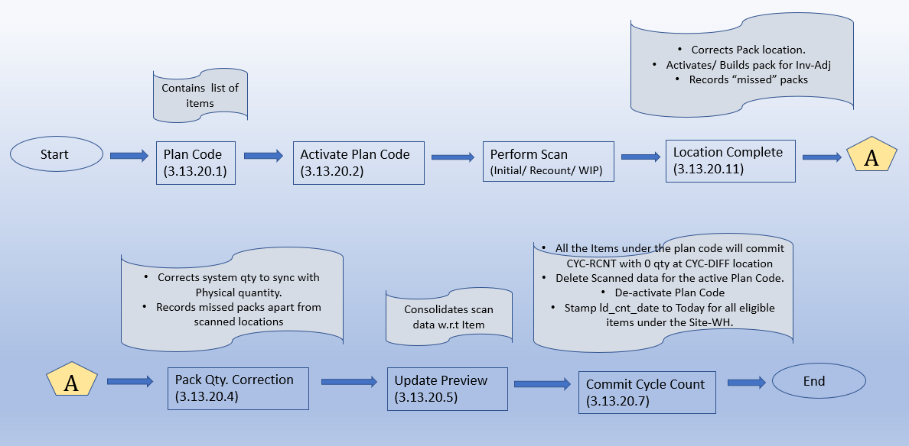

The AS transactions remain to be common for CC and RA.
Cycle count in QAD consist of the following steps:
- Counting plan is created in the system via upload program (3.13.20.1) or via maintenance program (3.13.20.13).
- Plan can be activated via 3.13.20.2 program. Only one plan can be activated at a time.
- Physical counting is done via scanning or via manual counting. Scanning process records results in QAD directly. Manual counting should be entered in the system via upload program (3.13.20.8 and 3.13.20.9 for serialized inventory and 3.13.20.10 for loose inventory). All locations must be counted (including Quality Hold location). Every not-counted inventory will be marked as Missed and written off.
- Online results/ progress of the counting can be checked in 3.13.20.12 browse.
- If counting results are loaded with XLS template – Location complete program must be run 3.13.20.11. Location complete in AS solution is done automatically after location is counted.
- 3.13.20.4 program must be run to correct qty in the “completed” locations. This program moves materials from/ to counted locations to CYC-DIFF location. Pack qty for serialized inventory and loose inventory are corrected. Missed serials from unscanned locations under Site-WH are identified at this stage.
- 3.13.20.5 Status update program must be run when all relevant locations are counted and corrected.
- Results on the counting with financial impact and tolerances can be seen in 3.13.20.6 browse. Results must be confirmed outside of the system by material manager/ plant controller/ plant manager if required.
- Recount may be initiated for some parts. Options are: AS solution for recounting or 3.13.20.9 upload program manual recounting. Remember that Recount via AS deleted all the serials in the location and considers the scan afresh.
- Location complete (3.13.20.11 or via AS inbuilt Location complete)/ Pack qty correction (3.13.20.4) and Status update (3.13.20.5) should be done again after recounting. Results of the recount may be checked in 3.13.20.12 browse for detailed scan and 3.13.20.6 for Summarized information.
- 3.13.20.7 Processes and finalizes cycle counting results.
- Validation can be done with a transaction history program 3.21.2.

Creating a plan
Before you can start your cycle-counting process you need to define the scope of the counting and limit the number of items that will be available for counting. Plan for a single day can include several items from different product lines.
- Plan can be created directly in the system using 3.13.20.13 program:
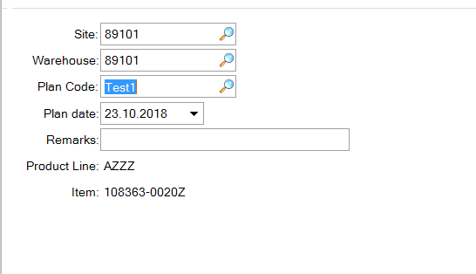
The same program can be used to modify/delete the items of the plan that has not been activated or processed yet.
If the Prod Line is entered and Item field is left blank then all items under the prod line will become part of the CC plan code.
At a time 50 items can be entered manually under a plan code.
Plan can be created outside of the system and loaded via special program 3.13.20.1:
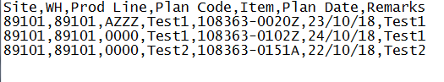
There should be an empty line at the end of the template
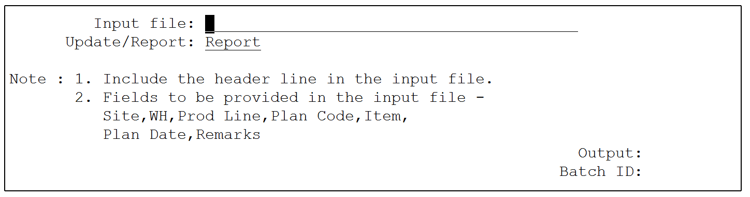
This program can be run either with Report mode or Update Mode.
It is recommended to run Report mode first and check if any errors occurred.
- All plans (plan codes) in the system can be reviewed with 3.13.20.3 browse:
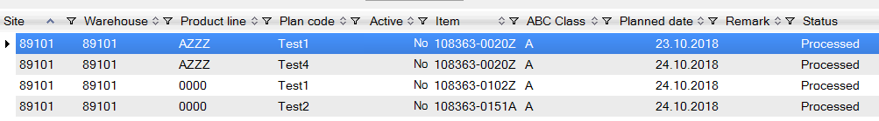
In the browse you can see what plans for what items are loaded in the system. Which plan is active and which plans are processed.

Activating the plan: 3.13.20.2
After you have your plan loaded/ created in the system – you must activate the plan. Only non-processed plans can be activated.
Note: Plan cannot be modified after it is activated.
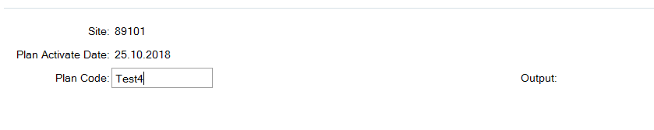
You can check the results in the output report or in 3.13.20.3 browse. As the plan code is activated the flag xccpl_status becomes Yes (can be seen in 3.13.20.3). As and when a plan code is activated the xccs_mstr record is created which can be seen in the browse 3.13.20.6. The xccs_mstr table creates list of Items which are part of the active Plan code. When a Plan code is deactivated its respective item list is deleted from the xccs_mstr table and the corresponding xccpl_mstr records will have xccpl_status assigned back to No.

Counting and recording results

- Using AS solution for Serialized inventory:
- Open Initial Cycle Count program via scanner/ handheld
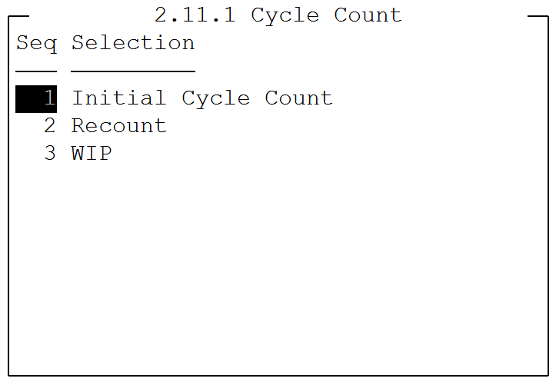
- Scan location ID (alternate location if applicable). F2 help provides the locations holding the inventory for the eligible list of items of the plan code.
- Scan Serial ID. Prefix “s”. F2 help provides the last level serials available under the scanned location. The records are created in the table (xccd_det). This table holds data of last level packs. Either child pack or unit pack.
If a serial which holds item which is not part of plan code then the transaction will throw error and skip it.
- Rescan a child pack/ unit pack in case of editing the quantity. If the last level pack is mixed, then an extra prompt for Item will appear to confirm the Item for which the quantity is being edited.
- Complete the location by pressing F10 in the scanner.
- Either move to the next location or mark the current location as complete via “Location Complete: Y”.
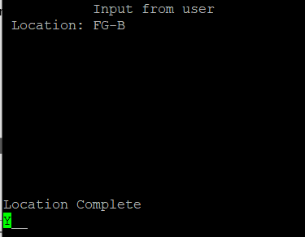
Note:-
- Initial and Recount AS transaction remains to be the same except for the following points mentioned below.
- Location once scanned and marked as complete (Location Complete: Y) via Initial count cannot be scanned again. To rescan a location, one must use Recount transaction.
- While performing Recount, all the serialized inventory records (in xccd_det) will be deleted from the respective scan location.
- A location can be scanned multiple times via Recount.

- Using AS solution for Loose inventory:
- Open WIP count program on your scanner/ handheld
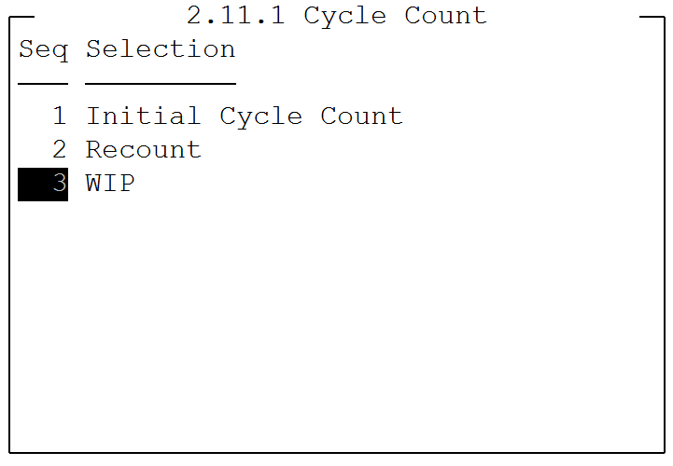
- Scan or type item number (with or without prefix)
- Scan or type location ID (not alternate ID)
- Optional: Enter lot information
- Optional: Enter Reference information
- Enter count results
- Complete the location by pressing F10 in the scanner
- Move to the next location

- Recording the result after manual counting (Serialized)
- Fill in template with counting results
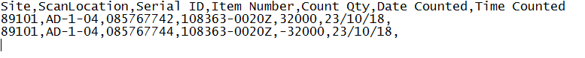
- Make sure that you have one empty line at the end of the template.
- Use upload program 3.13.20.8 to load the results:
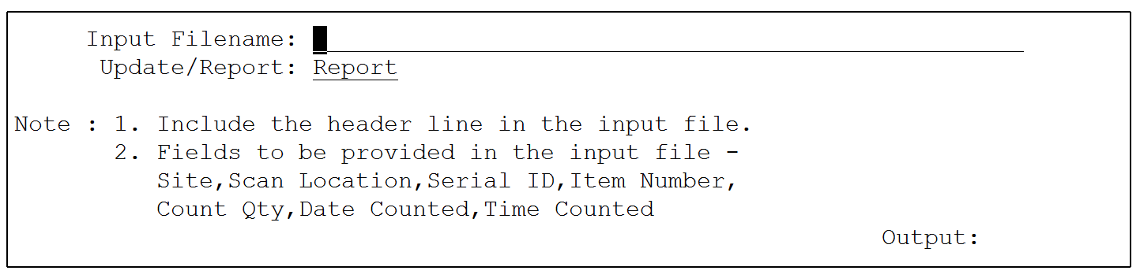
This program can be run in Report and Update mode. Recommended to use Report mode first.

- Recording the result after manual counting (Loose)
- Fill in template with counting results
- Make sure that you have one empty line at the end of the template.
- Use upload program 3.13.20.10 to load the results:
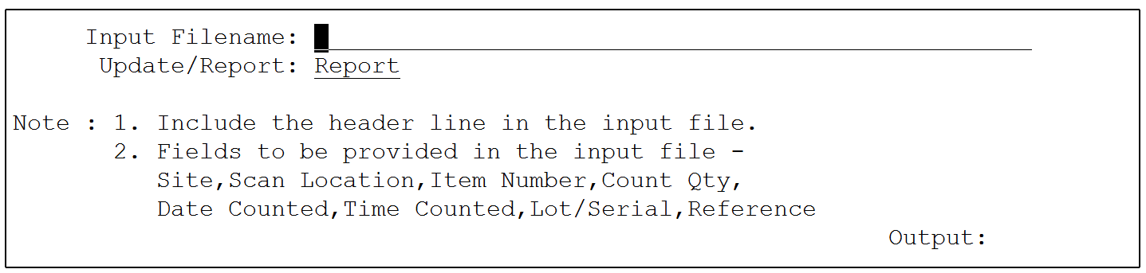
This program can be run in Report and Update mode. Recommended to use Report mode first.

- Checking the results in CC details browse: 3.13.20.12
The current results (ongoing scan) of the counting can be seen in the browse 3.13.20.12.
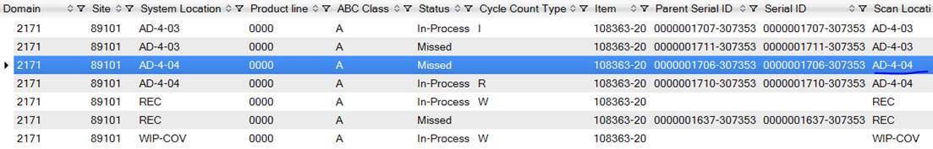

Location complete: 3.13.20.11
If counting results were loaded via excel templates or if AS solution location complete was not done for any reason – location complete process can be run manually with 3.13.20.11 program.
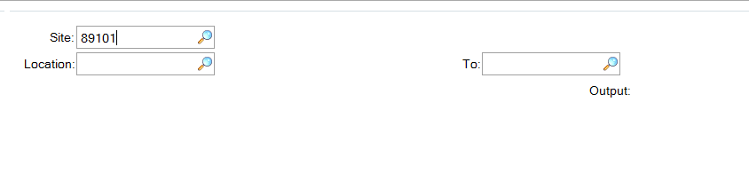
ou may do this for one location, range of locations or all locations (by leaving locations fields blank) in the system.
The Location Complete handles the below activities:-
- Correct the serial’s system location with the scan location if found to be different.
- Activate a serial if found to be of stage “Inv-Adj” and populate the inventory in the scan location.
- Pull out the missed serials from the scan location.

Pack quantity correction: 3.13.20.4
This program moves all the identified differences in the completed locations from/ to CYC-DIFF location.
This includes correction of pack quantities.
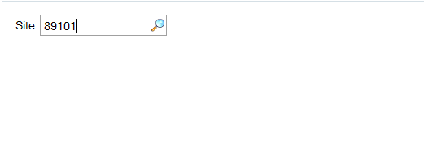
You just need to enter Site ID.
Also, this menu pulls out all the missed serialized and non-serialized inventory (holding eligible items) from the unscanned locations.

Counting Status Update: 3.13.20.5
It is only possible to complete this step after all counting is done.
Site ID is the mandatory field.
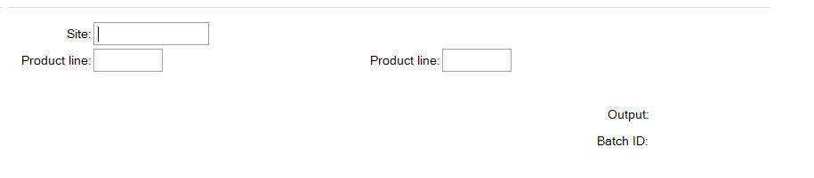
This menu helps the user to preview/ understand the impact if the plan code is committed via final menu 3.13.20.7. Also, it will stamp the xccd_det records as Processed (xccd_status). All the “In-process” records are converted to “Processed”. The status of records in xccs_mstr turns from blank to “In-process” (xccs_stat).

Reviewing counting results: 3.13.20.6
You can review the results of the couning at this stage using Status Browse 3.13.20.6
In this browse you can see if counting is in tolerance and what is a financial impact.
Use this report to get approval from Material Manager/ Plant Controller/ Plant Manager (as per BOS requirement)

Recounting and recording recounting results
- Using AS solution for Serialized inventory:
- Open Recount program via scanner/ handheld
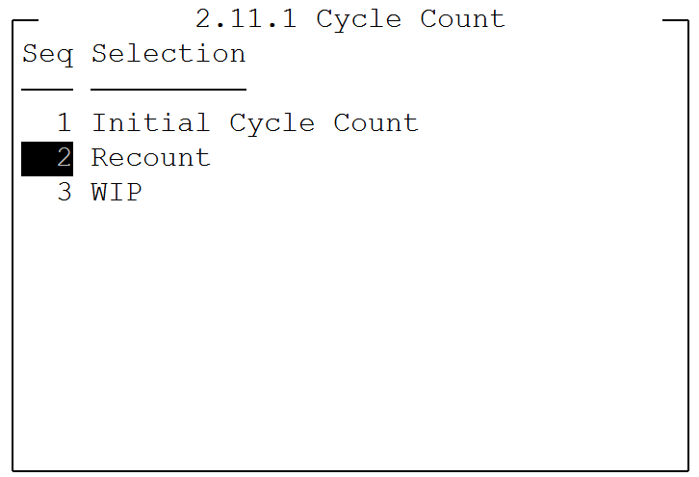
- Optional: scan or type product line
- Optional: scan or type (with prefix “p”) Item number
- Scan location ID (alternate location is taken)
- Scan all the serials for the “planned” items in this location
- Complete the location by pressing F10 in the scanner
- Move to the next location

- Using AS solution to recount Loose inventory:
- Open WIP count program on your scanner/ handheld
- Scan or type item number (with or without prefix)
- Scan or type location ID (not alternate ID)
- Optional: Enter lot information
- Optional: Enter Reference information
- Enter count results
- Complete the location by pressing F10 in the scanner
- Move to the next location

- Recording the result after manual re-counting (Serialized)
- Fill in template with re-counting results
- Make sure that you have one empty line at the end of the template.
- Use upload program 3.13.20.10 to load the results:
This program can be run in Report and Update mode. Recommended to use Report mode first.

- Recording the result after manual counting (Loose)
- Fill in template with counting results
- Make sure that you have one empty line at the end of the template.
- Use upload program 3.13.20.10 to load the results:
This program can be run in Report and Update mode. Recommended to use Report mode first.

- Checking the results in CC details browse: 3.13.20.12
The current results of the recounting can be seen in the browse 3.13.20.12. Recounted Inventory have Cycle-Count R.

Updating Status after recounting:
To process differences found during recount process one must run programs
- 3.13.20.11 – Location complete (see above)
- 3.13.20.4 – Pack qty correction (see above)
- 3.13.20.5 – Status update (see above)
- 3.13.20.6 – Review the results in Status browse for final confirmation:

Processing cycle counting results: 3.13.20.7

After you are ready to process results of the counting – execute 3.13.20.7 program.
This program is generating CYC-RCNT transaction for all inventory that is in CYC-DIFF location.
It will also close the active plan and mark it as Processed in Plan Browse (3.13.20.3)
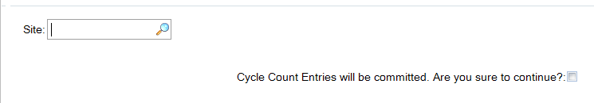
You need to confirm that you want to execute the transaction by checking the box.
This program performs the below activities:-
- Stamps count date (ld_cnt_date) as Today for all the eligible items (which are part of plan code) in all the locations wherever they have inventory under the site-WH combination.
Note:- Does not stamp count date in in_cnt_date.
- Decommissions the missed serialized inventory and the transfers the loose inventory to the CYC-DIFF.
- Missed non-serialized inventory also is transferred to the CYC-DIFF.
- Generates CYC-RCNT transaction for all the inventory that is in CYC-DIFF location. Even if there is no inventory for an eligible item of the plan code, it does generate CYC-RCNT in the CYC-DIFF location with 0.
- Sends the complete detailed table records (seen in 3.13.20.12) as webpage output and deletes the table (xccd_det) records.
- Deactivates the plan code. xccpl_status = NO.
- Summary table is stamped as “Processed” (xccs_stat = “Processed”).

Checking counting results in Transaction History: 3.21.2

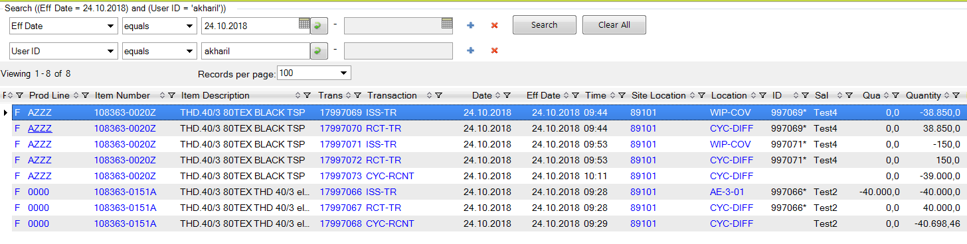
Recommended filters:
- Effective date: date of the counting
- User ID: global ID
- So/job: <Plan code>

*Location Check for RA Plan Code (3.13.20.16) :-

This is a standalone menu and can be run at any time.

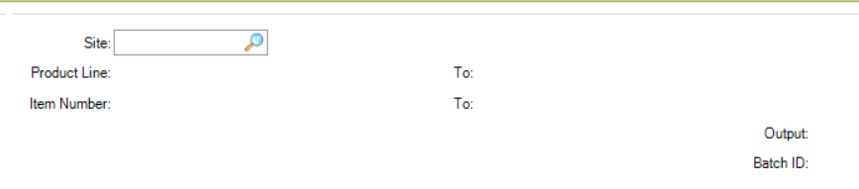

Provide Site. Product line and Item Number are optional.
The program traverses through all the items under the given criteria.
It checks the ld_cnt_date of the item under the given site. If all the ld_cnt_date fall withing the range of today to (today – pt_cyc_int) then the latest ld_cnt_date is picked and stamped to the in_cnt_date field.
If anyone of the ld_cnt_date is blank or ? then it skips such items and does nothing.

Miscellaneous Info:-

Records created in xccpl_mstr in case of CC plan code:-

Plan code | Item Number
CC1 | Item1
CC1 | Item2
CC1 | Item3
CC1 | Item4
CC1 | Item5

Record creation in xccs_mstr(while activation) in case of CC plan code:-

Plan code | Item Number
CC1 | Item1
CC1 | Item2
CC1 | Item3
CC1 | Item4
CC1 | Item5

Data creation in xccd_det shown below:-
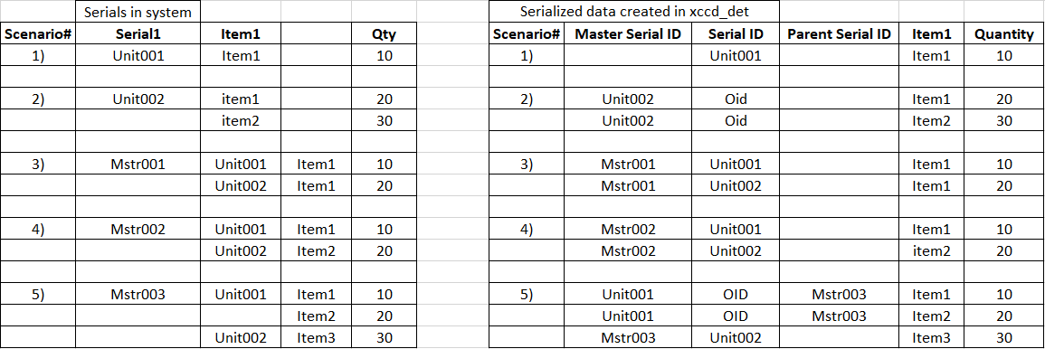

Status of customized tables during each stage:-

Tables Vs Stage | Scanning | Location Complete | Preview Update  (3.13.20.5) | Plan code commit  (3.13.20.7)
xccd_det (serialized)  (Initial/ Recount) | Pending | In-process | Processed | records deleted
xccd_det (non-serialized)  (WIP Count) | In-process | In-process | Processed | records deleted
xccs_mstr | - | - | In-process | Processed

